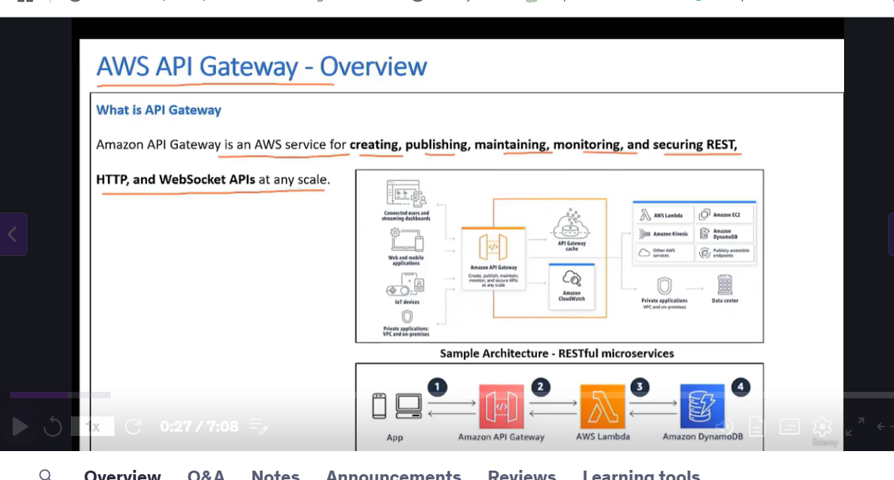

Amazon API Gateway is an AWS service for creating, publishing, maintaining, monitoring, and securing REST, HTTP, and WebSocket API at any scale.

Rest APIs, these can be consumed and invoked by any of the interfaces shown

you could have a web mobile application, Iot device, connected users, etcetera.

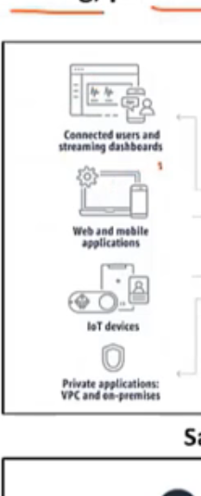

* Interfaces can make an API request. Then Amazon API Gateway will authenticate and authorize those APIs and invoke the services
* AWS, Lambda, Amazon, EC2 Kinesis, Amazon DynamoDB
* It could be any publicly accessible HTTP endpoint, and it can also connect privately to your data center.

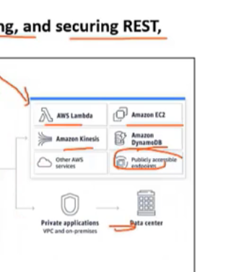

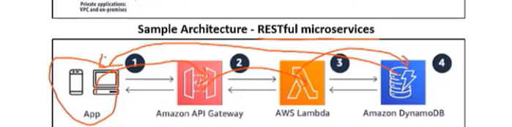

* Web or mobile app will make a request to this API Gateway
* API Gateway will authenticate and authorize that request.
* And if everything is fine, it will invoke the lambda function.
* Then this lambda function is going to make a call to the backend, retrieve the data,

pass it on to either the web or mobile interface.

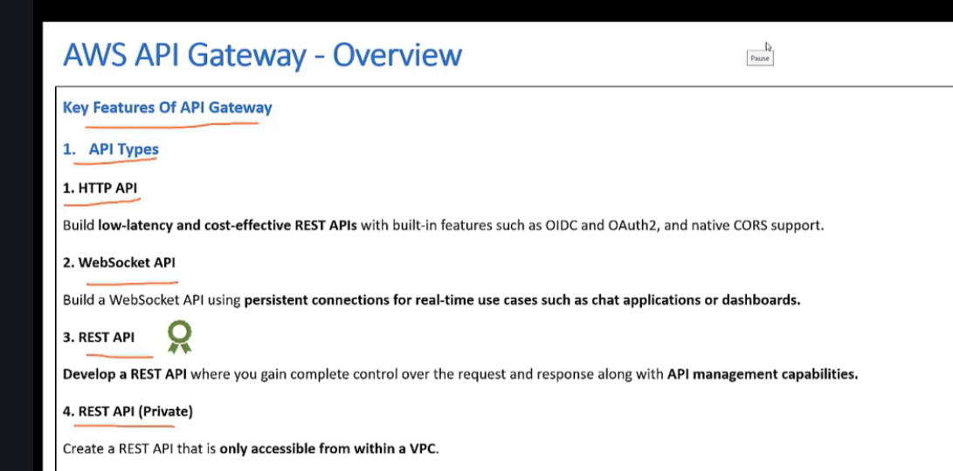

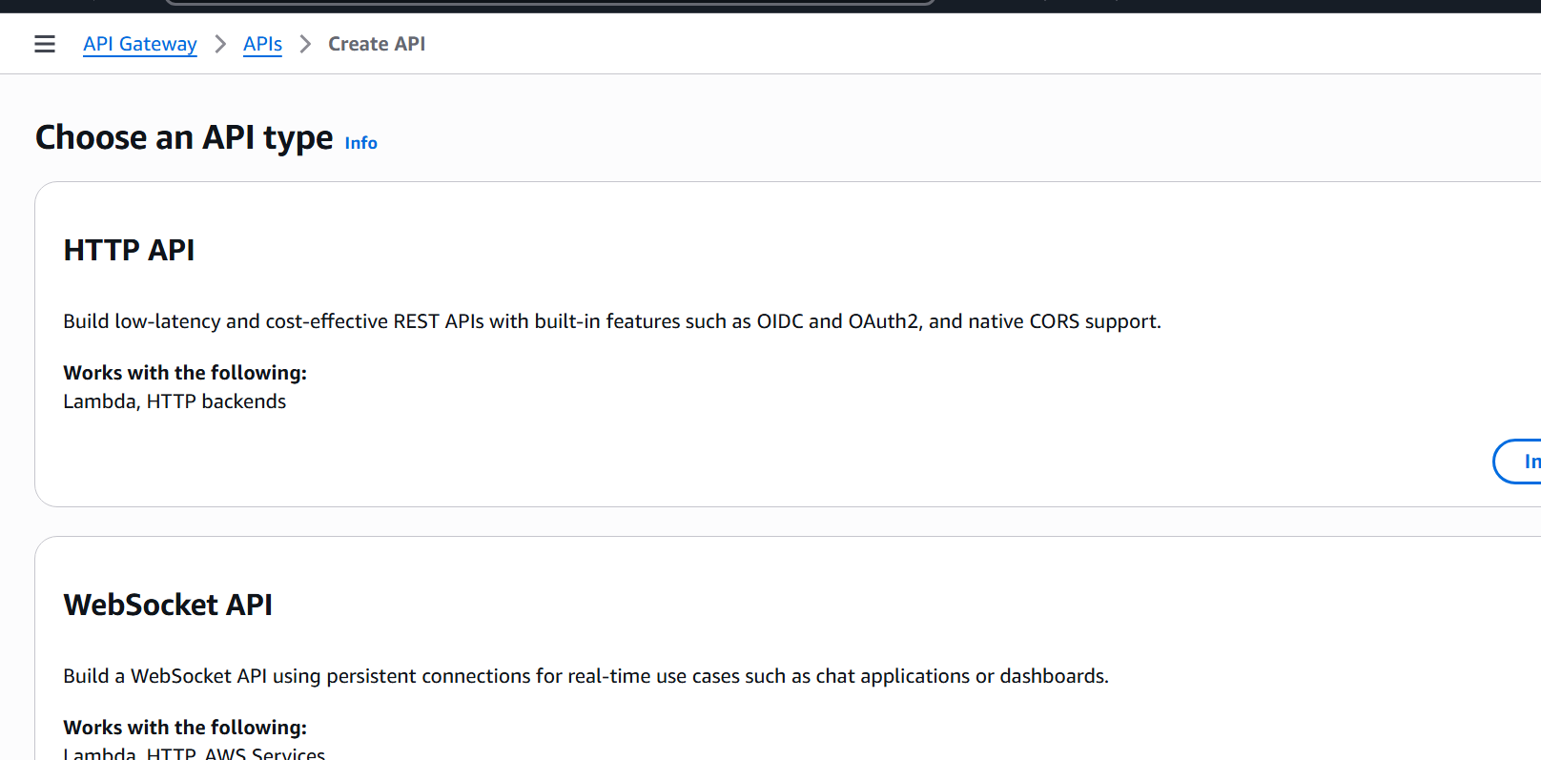

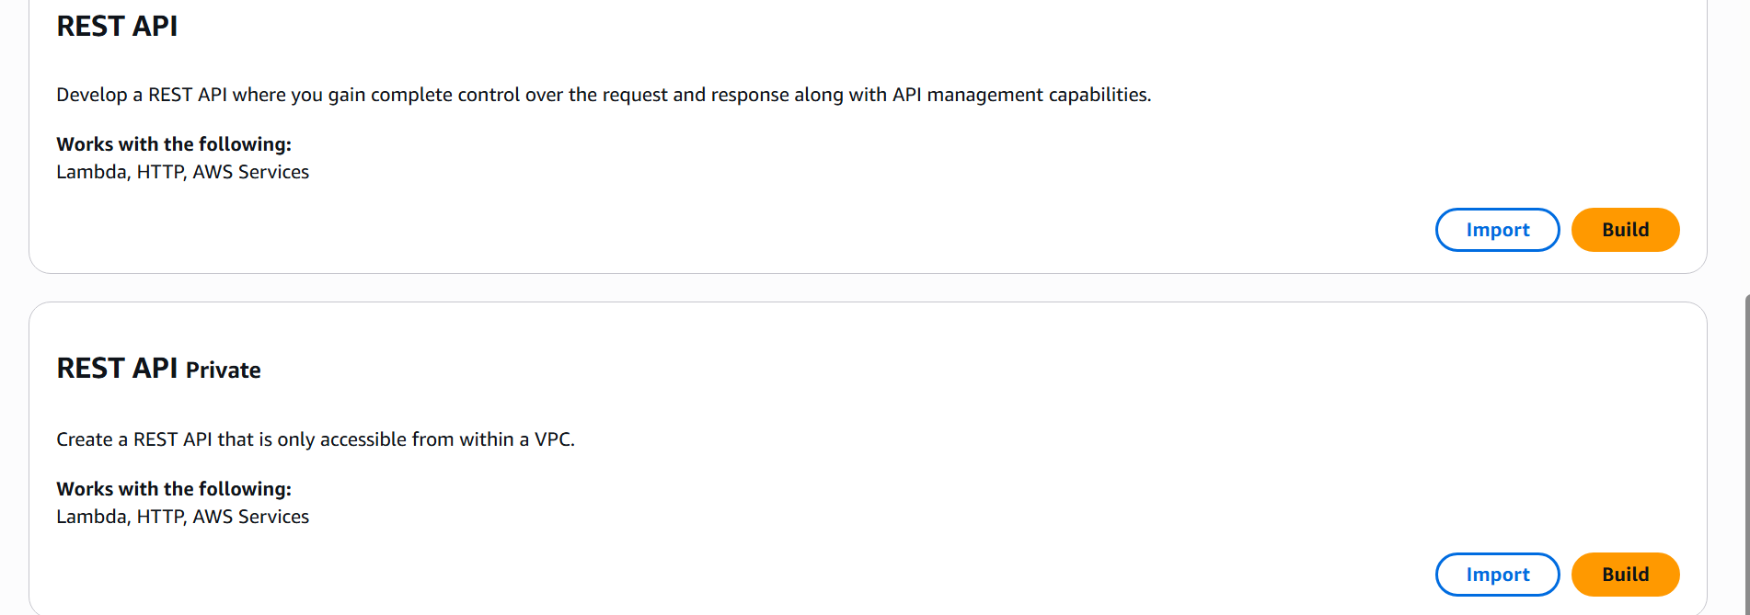

**HTTP API**

Build low-latency and cost-effective REST APIs with built-in features such as OIDC and OAuth2, and native CORS support.

**Works with the following:**

Lambda, HTTP backends

**WebSocket API**

Build a WebSocket API using persistent connections for real-time use cases such as chat applications or dashboards.

**Works with the following:**

Lambda, HTTP, AWS Services

**REST API**

Develop a REST API where you gain complete control over the request and response along with API management capabilities.

**Works with the following:**

Lambda, HTTP, AWS Services

**REST API Private (Banking Domain)**

Create a REST API that is only accessible from within a VPC.

**Works with the following:**

Lambda, HTTP, AWS Services

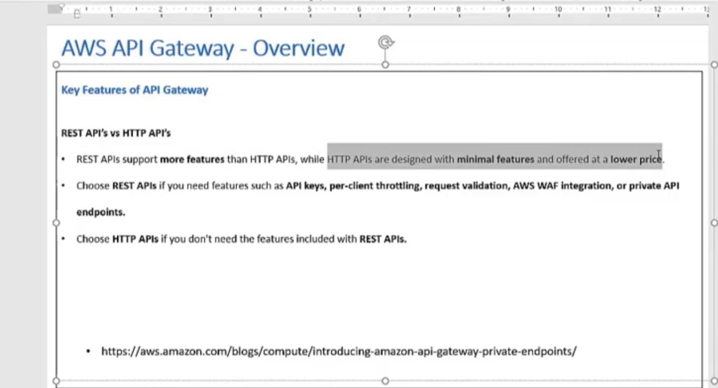

Click on Rest API🡪 Build 🡪 Create REST API 🡪 Example API 🡪 New API 🡪

**API name:** DemoApi

**API endpoint type:** Regional

###################################################################################

API End point types:

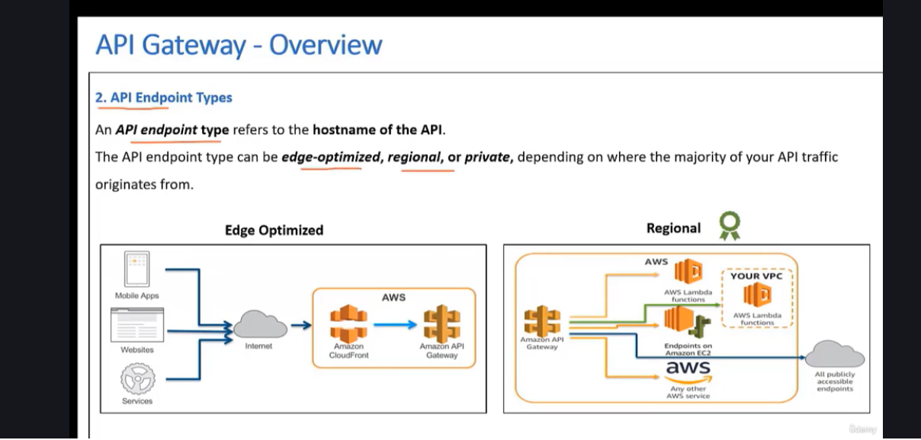

Edge Optimized : CDN

Have the API gateway and you can front end with the Amazon CloudFront. Requests coming in from any part of the globe, they can be routed to the Amazon CloudFront And then through the AWS network, they will be routed to Amazon API Gateway So this reduces the latency.

Regional: India

Regional API gateway and the users from that region, API gateway and then it can route it to any of the AWS service providers,

Lambda or endpoints on Amazon, EC2, etcetera.

3rd Type: Private

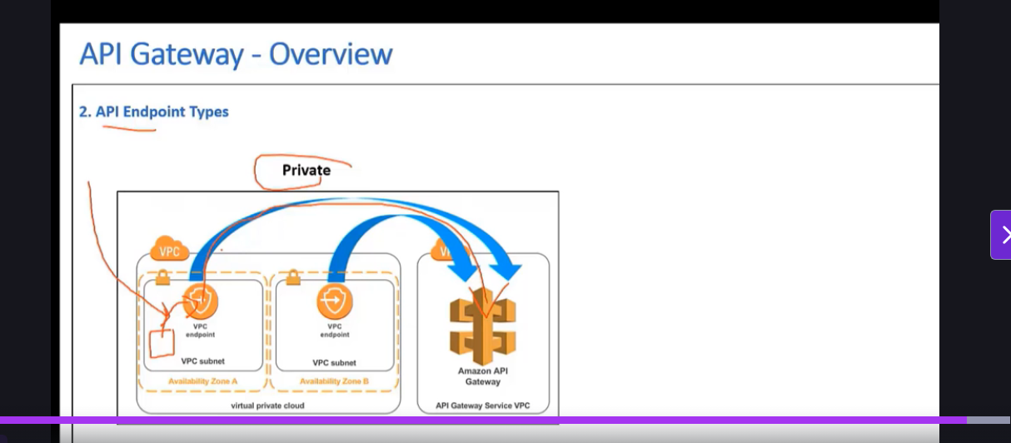

EC2 🡪 VPC endpoint in private network

Banking domain

* Not over the Internet but over a private network.
* This is a request that is routed, it needs to be routed to your VPC first,

  an EC2 or any other AWS service.

* Service is going to route it to the VPC endpoint.
* Routed through the AWS private network called as Privatelink on onto this Amazon API gateway. This cannot be accessed from the internet.

Regional

API Gateway🡪 Rest API🡪 Build🡪 New API🡪 API Endpoint Type(Regional)🡪 Create API

**Resources - DemoApi (94dm0q7r89) 🡪 REST API Id**

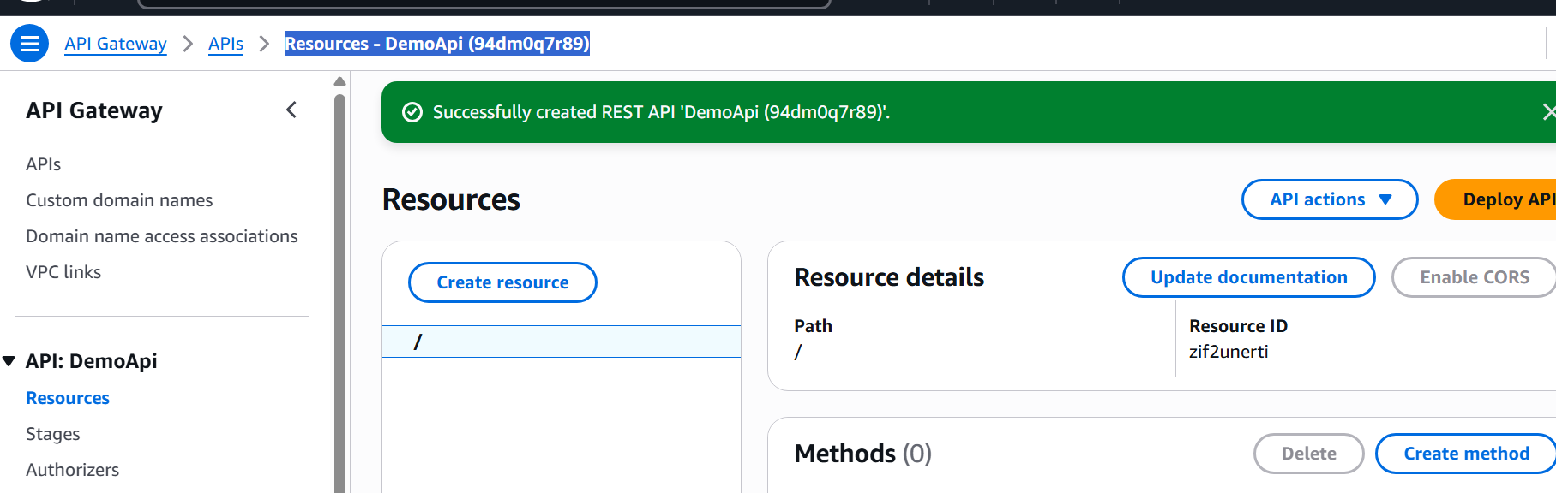

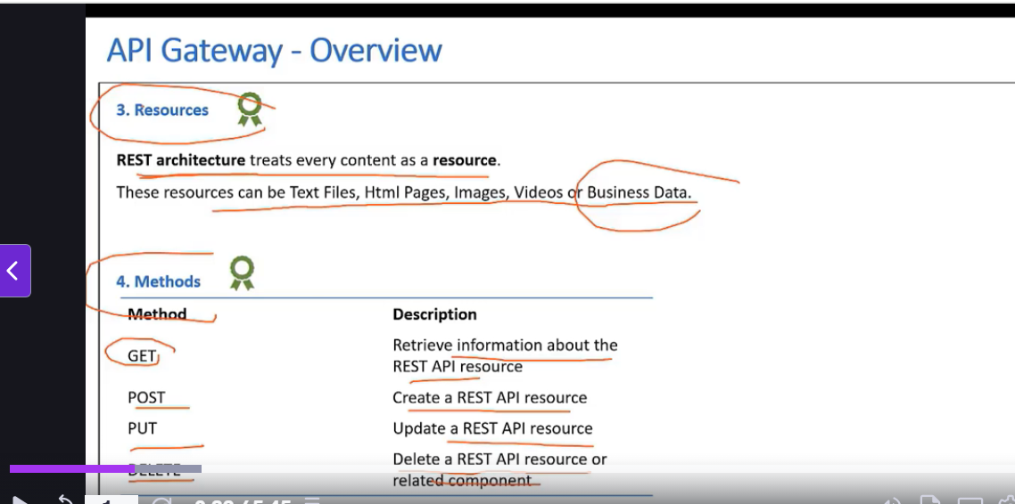

1. Create resource and method

Create Resource

* 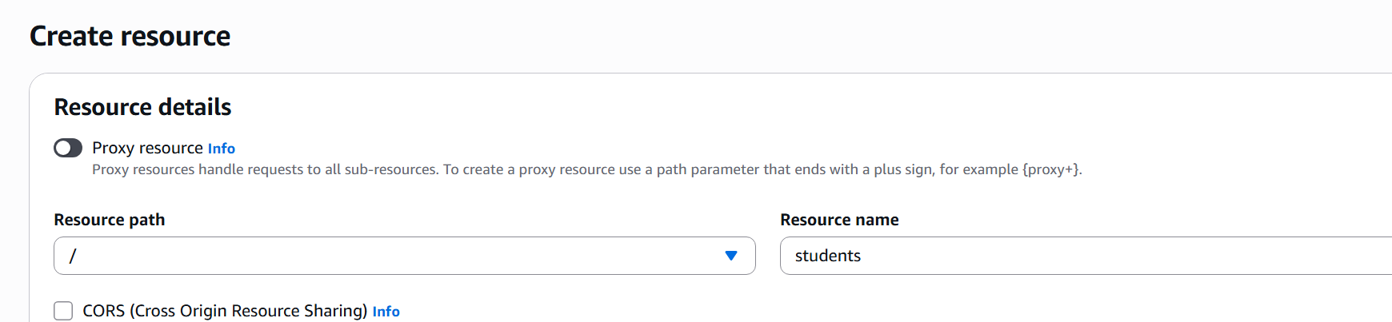

Resource path : /students

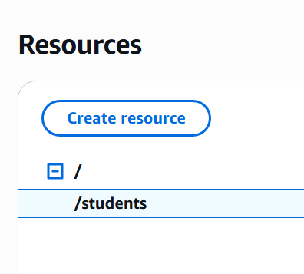

Create Method:

Method Type: Get

Integration Type:

Lambda

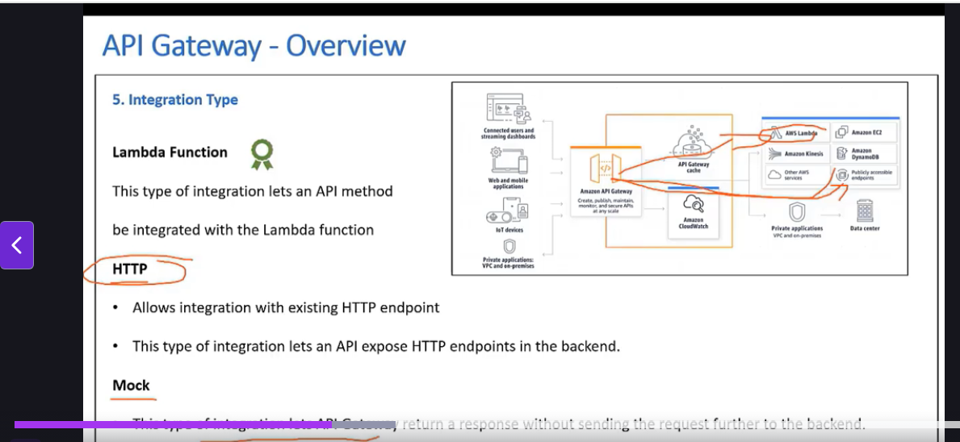

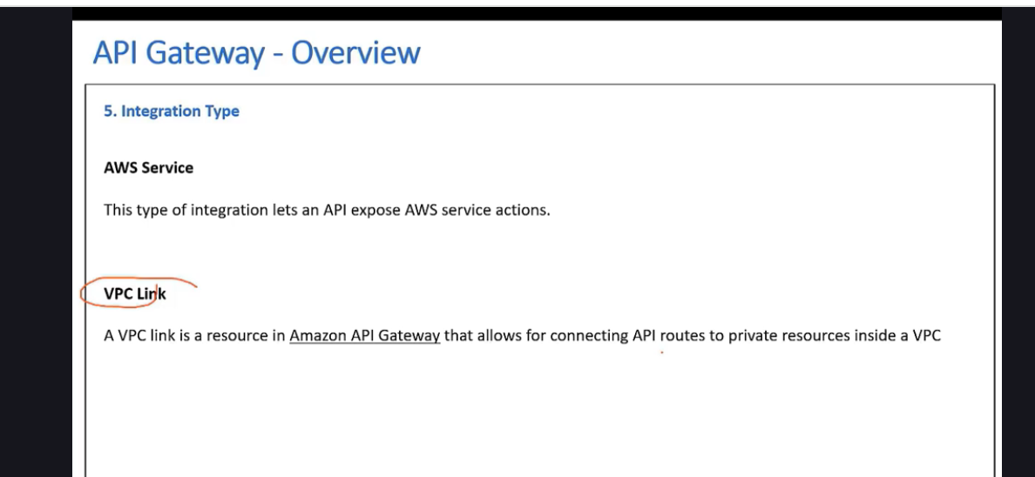

#################################################################################

* API Gateway with Lambda
* Any publicly accessible HTTP endpoint, so you can integrate. Amazon API Gateway with any HTTP endpoint.
* mock means is that you will have a type of integration with API gateway where the request is not sent to the backend. Its only used for testing purpose
* AWS services  Kinesis DynamoDB EC2.
* VPC link for VPC link is usually used when you are trying to connect API gateway to a resource within your own VPC. Private Resource inside a VPC
* you can also use Lambda proxy integration. So API Gateway can also do some kind of a transformation if there are any incoming requests.
* But when you use Lambda Proxy integration, what it will do is it will pass the request as it is to a lambda function and it will not do any kind of transformation.

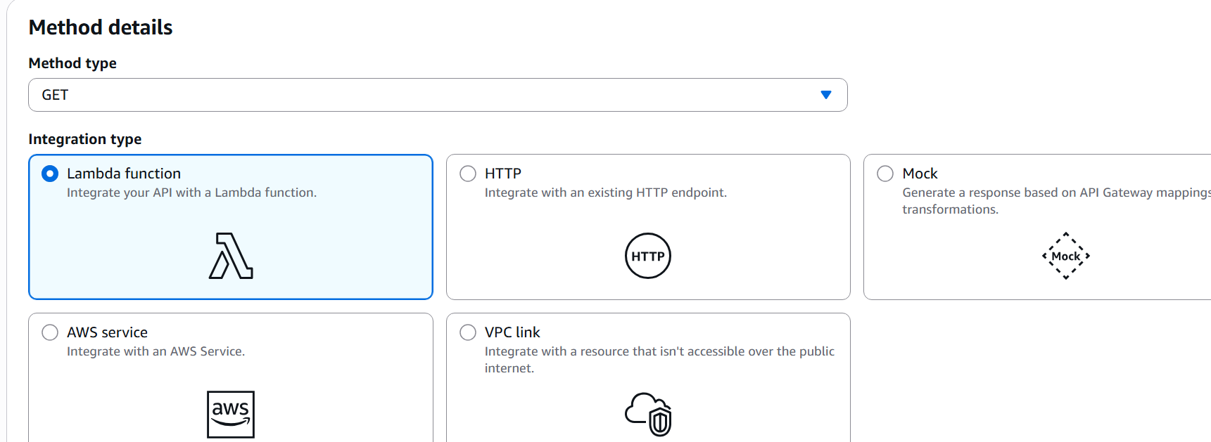

Lambda Function:

**Name:** ApiGatewayOverview

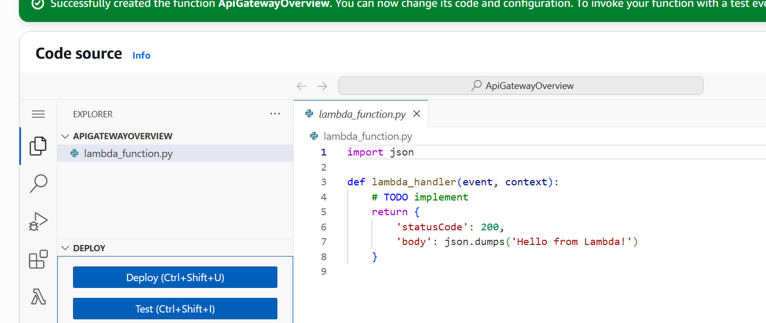

########################################################################################################

**Create method:**

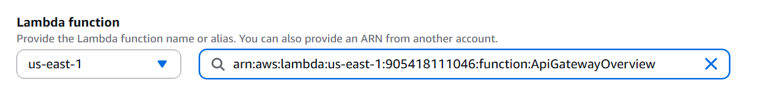

**Create Method:**

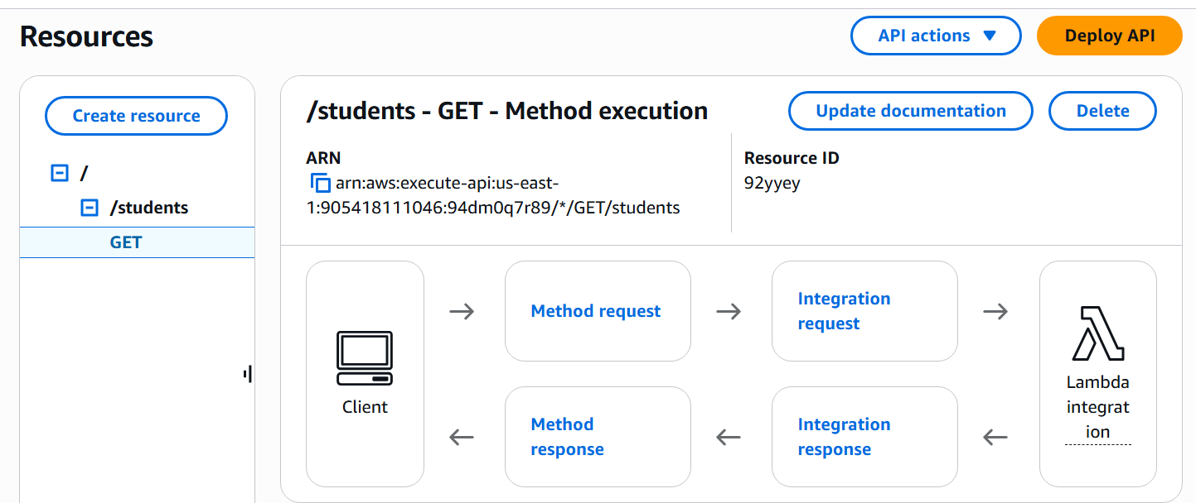

Method Request:

Authorization : IAM

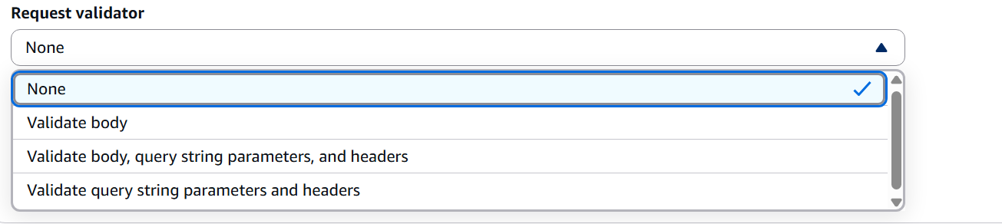

Once Client make a request 🡪 method request

* you can configure what kind of authorization you will use and what are the parameters that will be allowed.

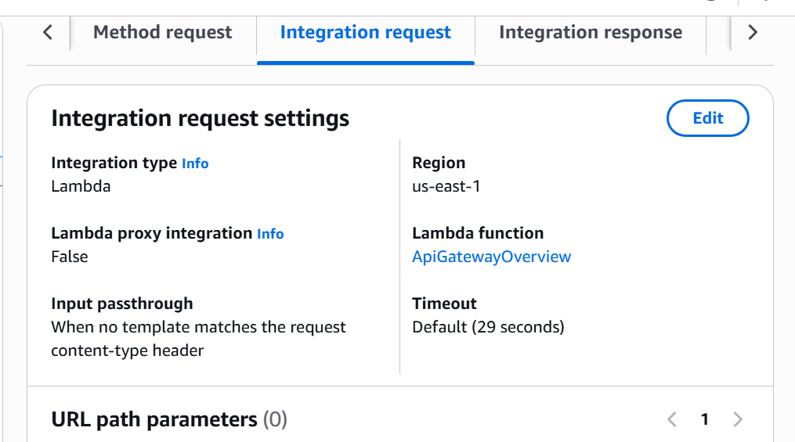

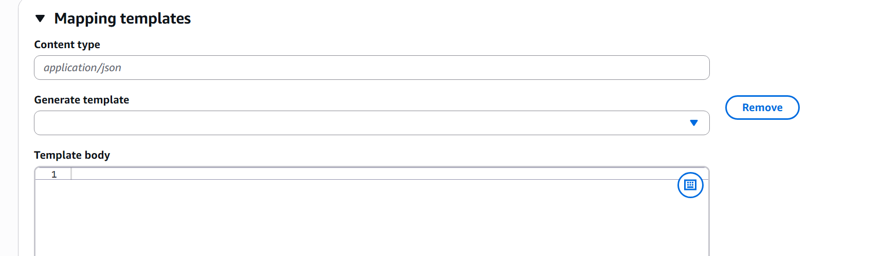

Integration Response:

Mapping template:

Mapping template using the velocity template language, you can modify the incoming request based on what is expected at the back end.

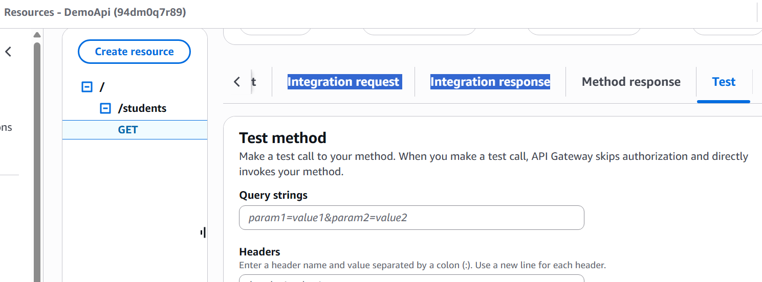

What integration type

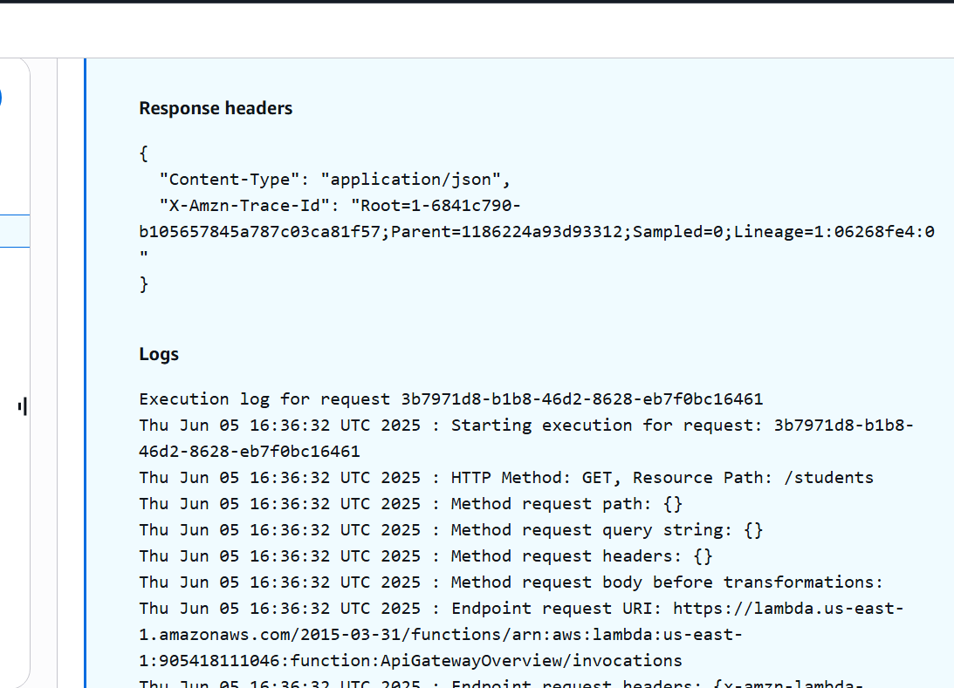

Now Deployment:

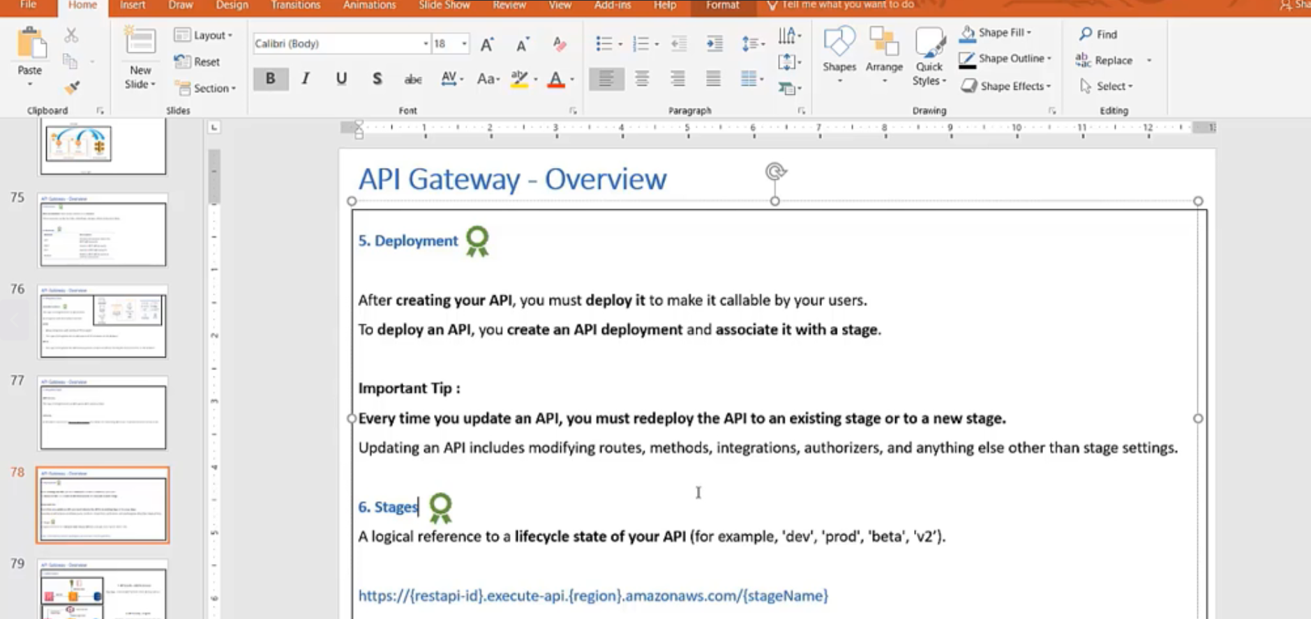

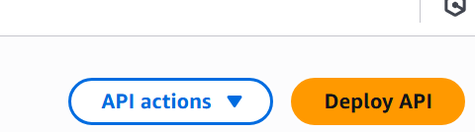

Deploy API🡪

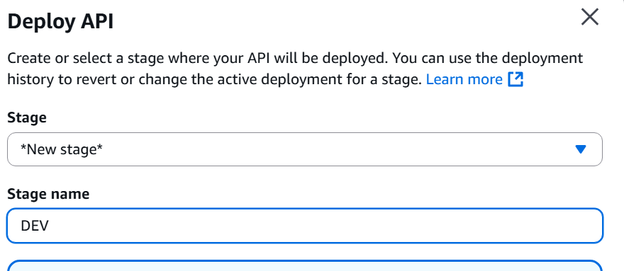

Deploy

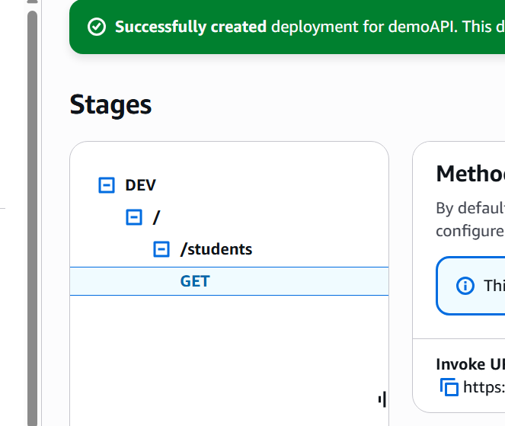

Invoke URL: <https://72yykmivt1.execute-api.us-east-1.amazonaws.com/DEV/students>

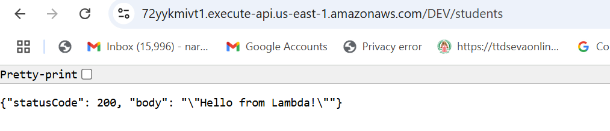

<https://72yykmivt1.execute-api.us-east-1.amazonaws.com/DEV/students>

https://{restapi-id}.execute-api.{region}.amazonaws.com/{stageName}/{resource}

USAGE PLANS:

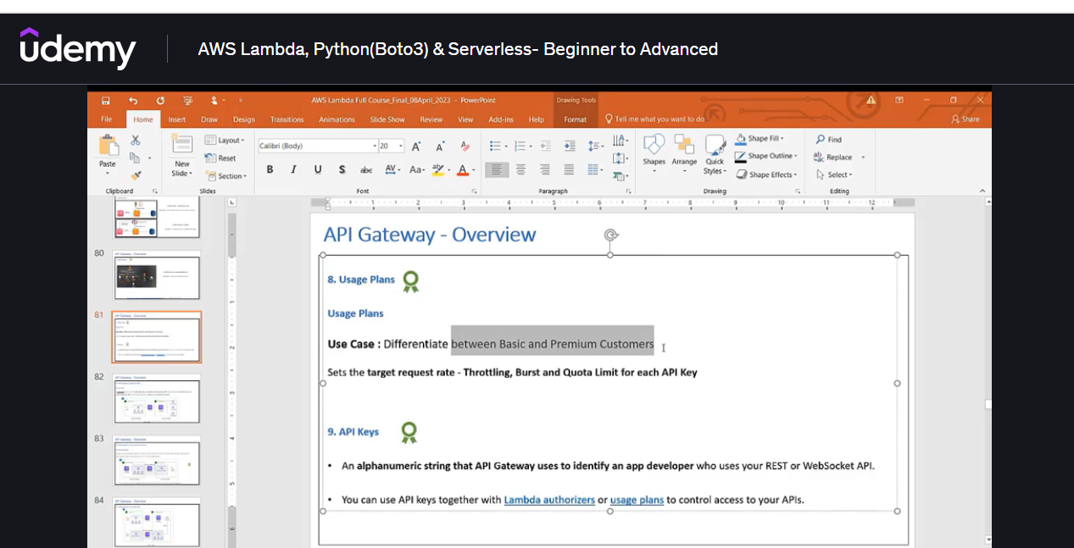

Basic Usage Plan:

Name: **BasicUsagePlan**

Rate: 5 5 requests per second

Burst : 2 2 requests

Requests: 50 50 requests per month

API Keys:

**Create API key 🡪 Demo**

**ggc5aeh83T2QYZsvabznS7V4YeNrSHCq163C61R3**

**Authentication and Authorization:**

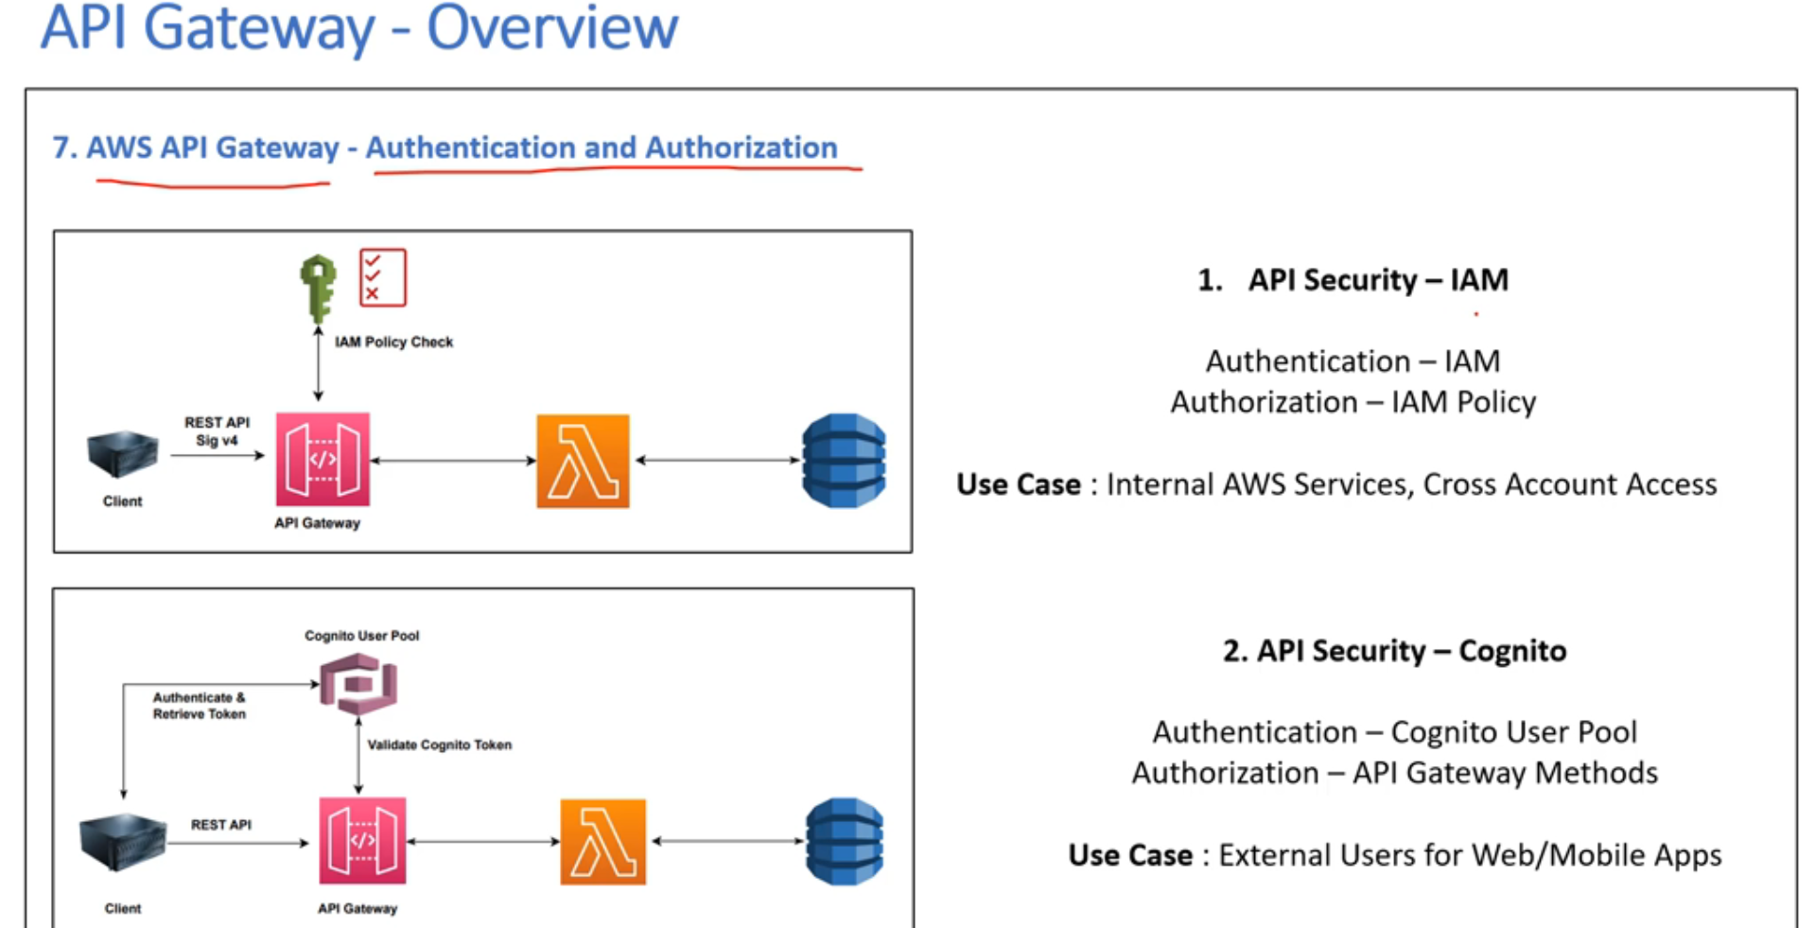

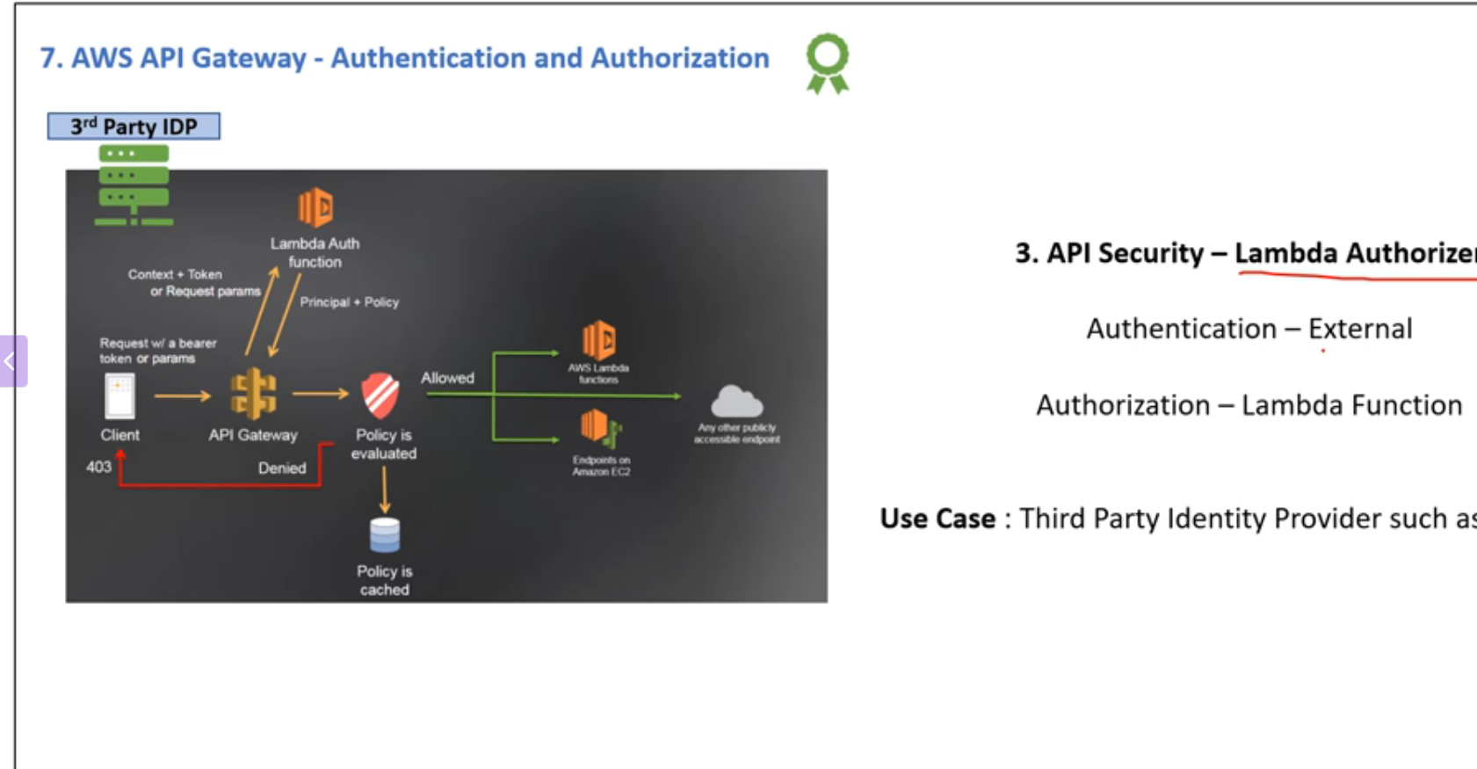

1. **AWS IAM service:**

Use AWS, IAM for authentication and authorization is done through the IAM policy attached to that IAM role.

* Request is coming from internal AWS services. So it can be an AWS service within the same account or it could be a cross account access.
* In this scenario you use AWS, IAM for authentication and authorization is done through the IAM policy
* Client can be any AWS service such as EC2 within or cross account.
* Now this client, an AWS service makes an API call using the Sigv4 capability to API Gateway.
* The API gateway has an integration with the IAM service, so it will evaluate the IAM role attached
* Validate the IAM role and policy with this AWS IAM service.
* And if everything works okay then it is going to enable access to the back end.
* If the request is coming from the same AWS account, then you can just use the IAM role and attach policy.

External:

But if it's a cross account access, then you have to additionally use a resource policy within the AWS API gateway.

METHOD request

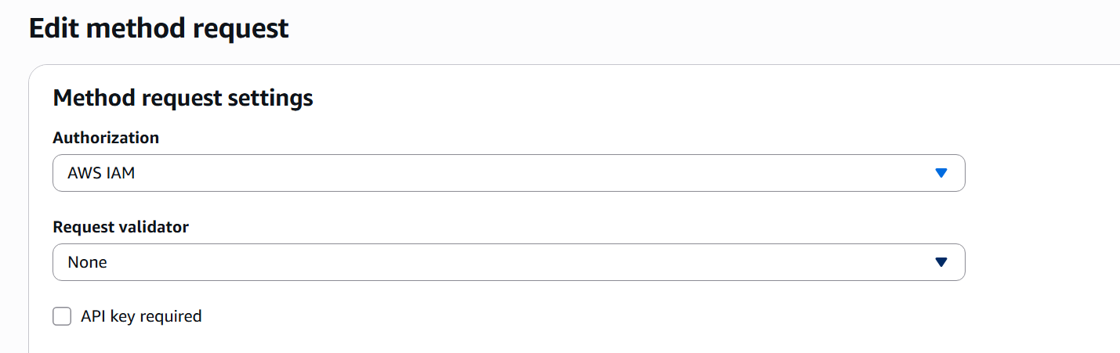

Save

For cross account

Click on “Resource Policy”

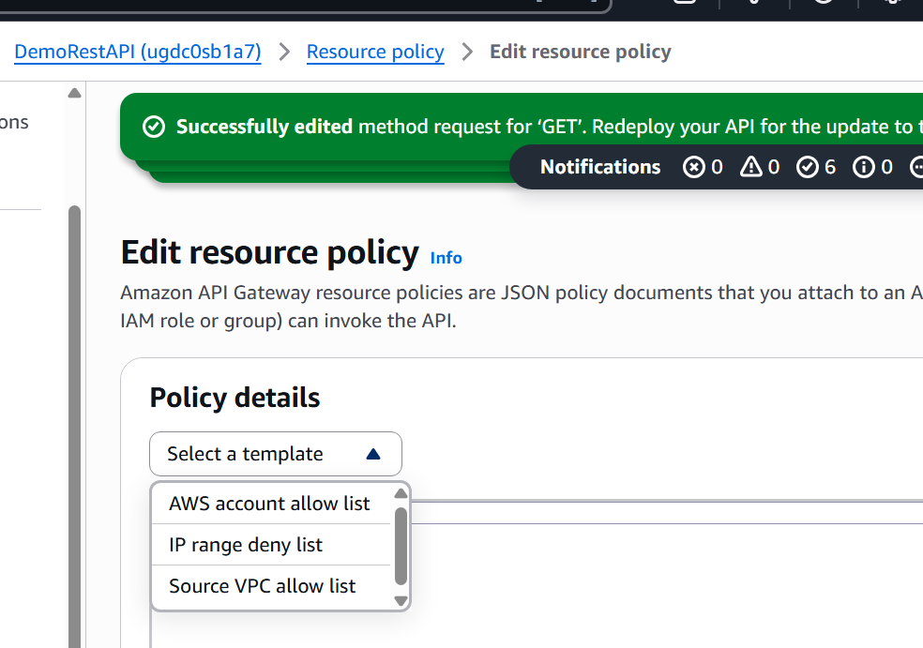

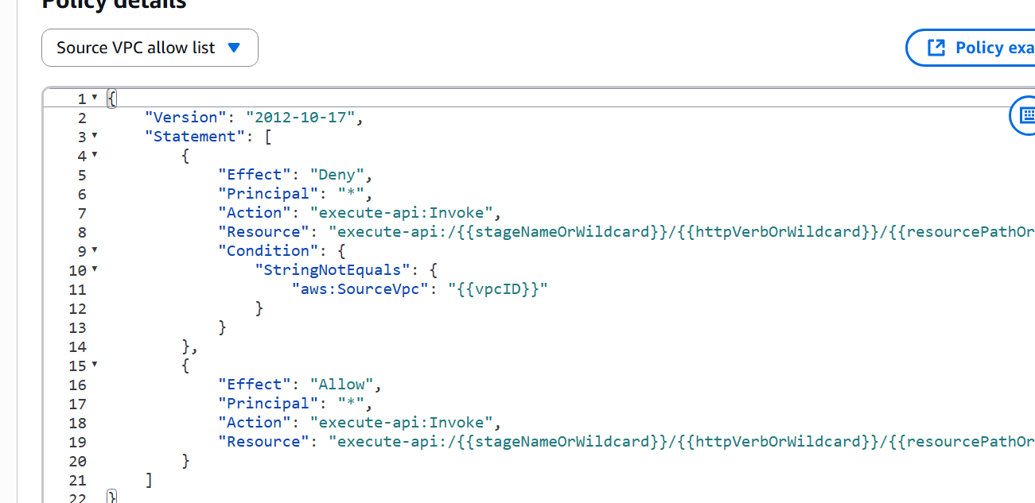

IP range/Source VPC/AWS account list

2nd Option:

API security🡪 Incoginto mode

Use case: External users for Web/Mobile Apps

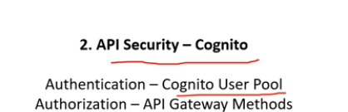

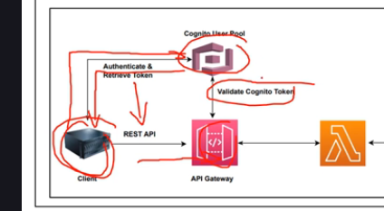

* Client who is trying to make a rest API call via the API gateway.
* Client would first do is it will make a request to this cognito, user pool and cognito.
* User pool should already have the identity for this client.
* So once he makes a request, it will authenticate the request and if all goes well, it will provide it with a token.
* So this client would now have a token.
* Client is going to make a rest API call along with the token that has been provided by the

Cognito user pool and it will make that request to the API gateway.

* Request comes to API Gateway, the API gateway already has an integration with the Cognito
* User pool, so it will validate this token provided by the client with the cognito user pool.
* The token is validated then it will allow the request to come to the back end.

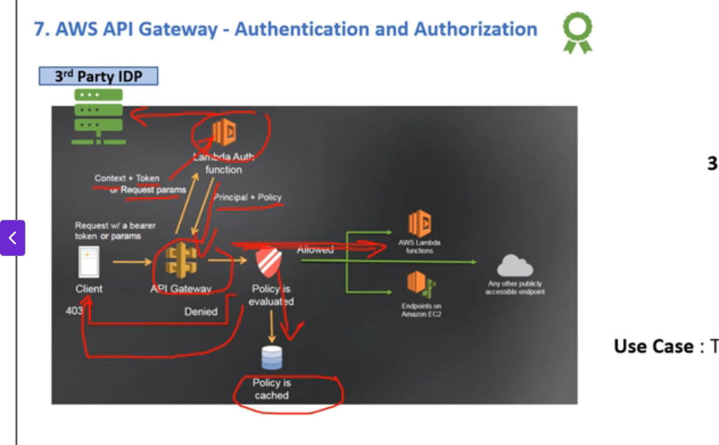

* The third approach and the most common one is called as lambda authorizer.
* So the use case for this is mainly when you want to authenticate your request using the third party identity provider.
* So here the authentication would be done externally by this third party identity provider and authorization

would be done by the lambda function.

* Client, which is going to make a request to this third party identity provider for authentication once it sends the request and if it is validated, the third party identity provider is going to pass on a bearer token or some parameters to this client.
* So once this client gets the bearer token, it is going to make an API request to this API gateway.
* Then this API gateway is going to pass on this token or request parameter along with context to the lambda function.
* This lambda function where you will have to write a little bit of code is going to validate this token or request parameter with this third-party identity provider.
* And if the request is validated, then it is going to pass on the principal and IAM policy back to this API gateway and this request from the client is allowed to access the back end and for future use.
* This policy is evaluated in the cache attached to this API gateway and if the request is denied then it goes and sends a 403 back to the client.
* So this is how you can utilize the lambda authorizer for authentication and authorization.

Click on Authrozers:

Authorizers🡪 New Authorizers🡪

**Authorizer type:**

1. **Lambda**
2. **Cognito**

* **Lambda Function**
* **Lambda Invoke Role – IAM policy**
* **Lambda event payload 🡪 Token or Request**

**Token Source / Token Validation**

* **Authorization caching (Caching the policy)**

**Cognito:**

**Cognito user pool:**

* **Token source:**
* **Token validation – optional**

API integration and Private APIs

1. Advanced concept, but nonetheless it is used a lot in the enterprise setting.
2. API endpoint types private, where we said that this Amazon API gateway is only accessible from a VPC and not directly from the internet.

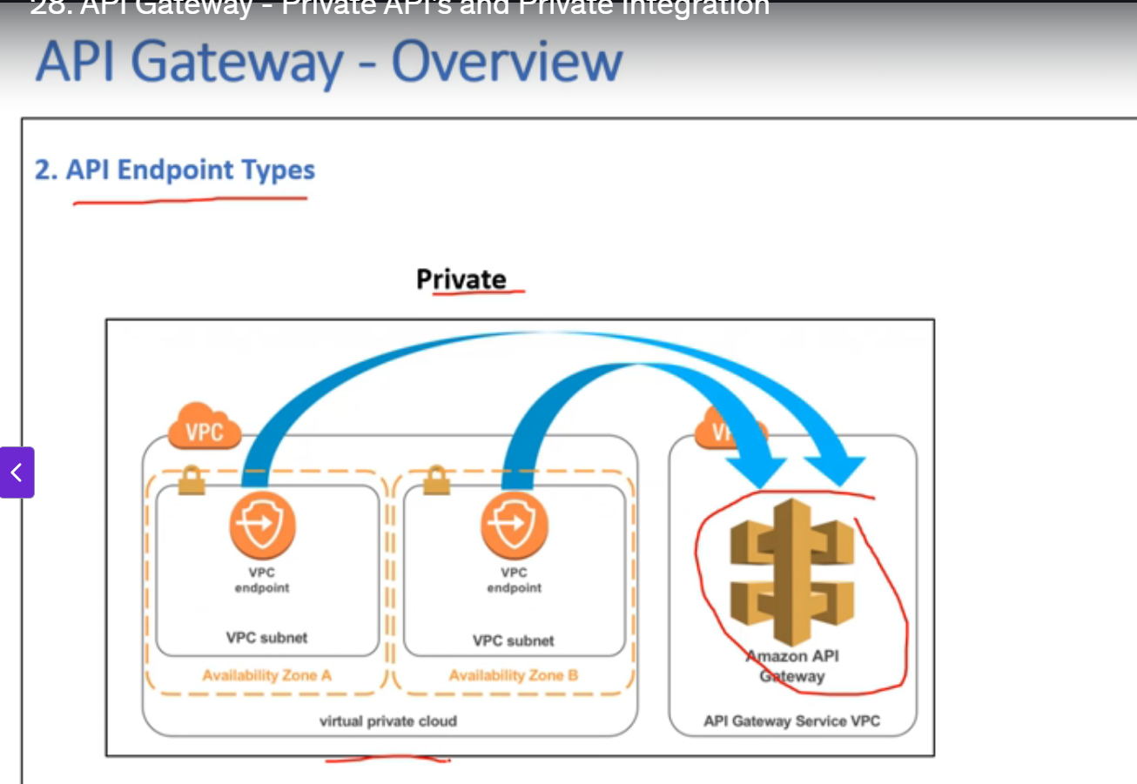

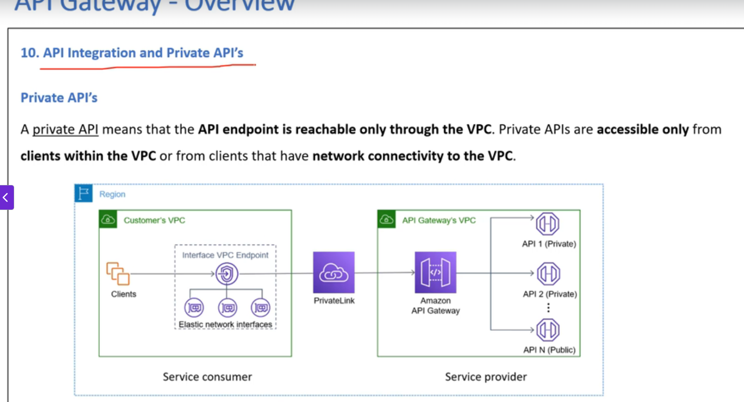

Amazon API gateway.

* One thing you need to remember about Amazon API Gateway is that it is not deployed in the customer VPC.
* It has its own API gateway VPC, very similar to the lambda function.
* So now say I want to access this Amazon API gateway which is deployed in this API Gateway VPC.

a Client here, it can be any service such as EC2, lambda, etc

b. request is routed to an interface VPC endpoint which you have to create within the VPC.

C. create the interface VPC endpoint, it will create an elastic network interface and all the requests are routed to this from this, the request will be routed to this Amazon API gateway on AWS Privatelink,

which is an AWS service to route any traffic on AWS private network and not through the internet.

d. So once the request reaches this Amazon API gateway, then it will authenticate and authorize the rest

API call. And if everything works okay, then it is going to allow access to the backend.

e. So in this case you can see here the customer VPC from the where the request originates is the service

consumer here and Amazon API Gateway VPC is the service provider.

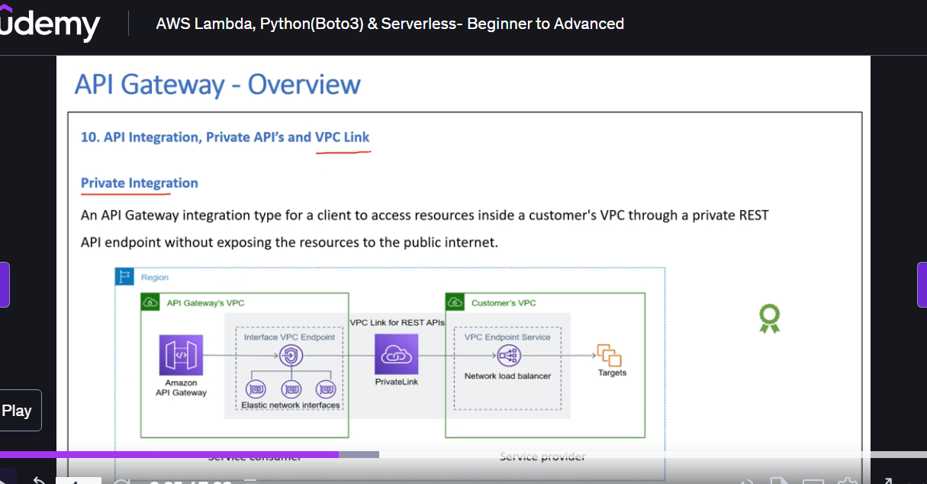

* So now say you have routed the request from your VPC to this Amazon API gateway on a private network

VPC link.

* But now this Amazon API gateway needs to access Say here you have an RDS database in the private subnet of the customer VPC. So you have the RDS, which is the customer VPC in a private subnet.

So how does this Amazon API gateway access, this particular RDS instance in the customer VPC?

* So what you will need to do is you will need to again create the interface VPC endpoints within this

VPC and then all the traffic that needs to be routed to this RDS will be sent to this elastic network

interface that gets created as part of the interface VPC endpoint.

* And then this traffic would be routed using the private link to this network load balancer that you

need to create in case you want to use the private integration approach.

* So once the request comes to this network load balancer, then it is going to route the traffic to this

RDS instance.

* So all the requests that go from this VPC to the customer VPC are through the private network called

as PRIVATELINK.

* So typically in the API gateway terms, what you need to do is you need to create the network load balancer

and then you will have to use this VPC link for rest APIs to create this configuration.

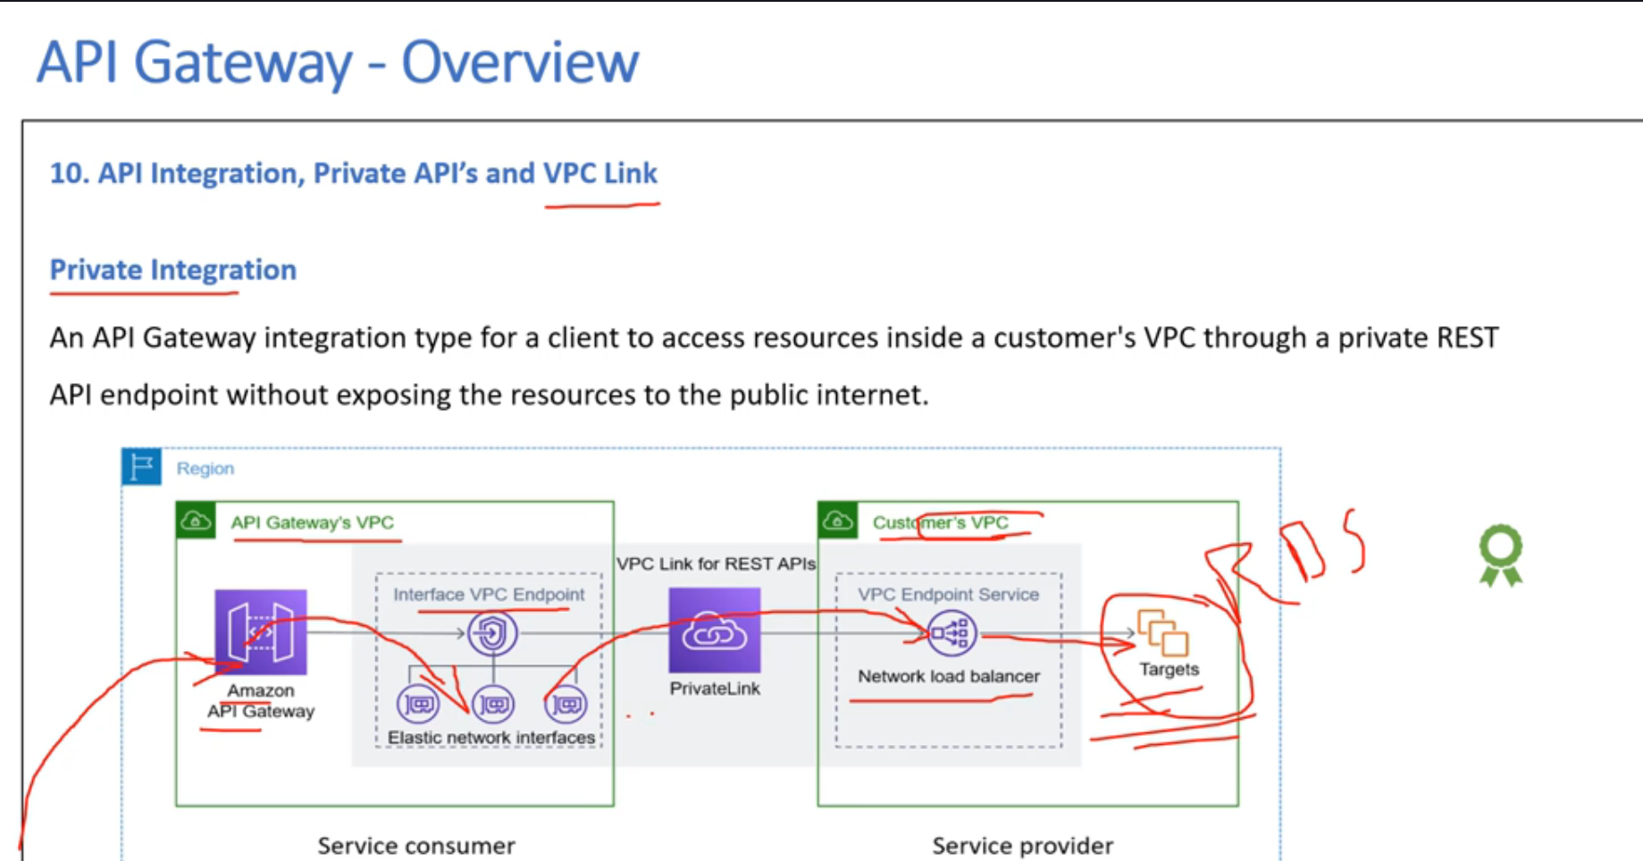

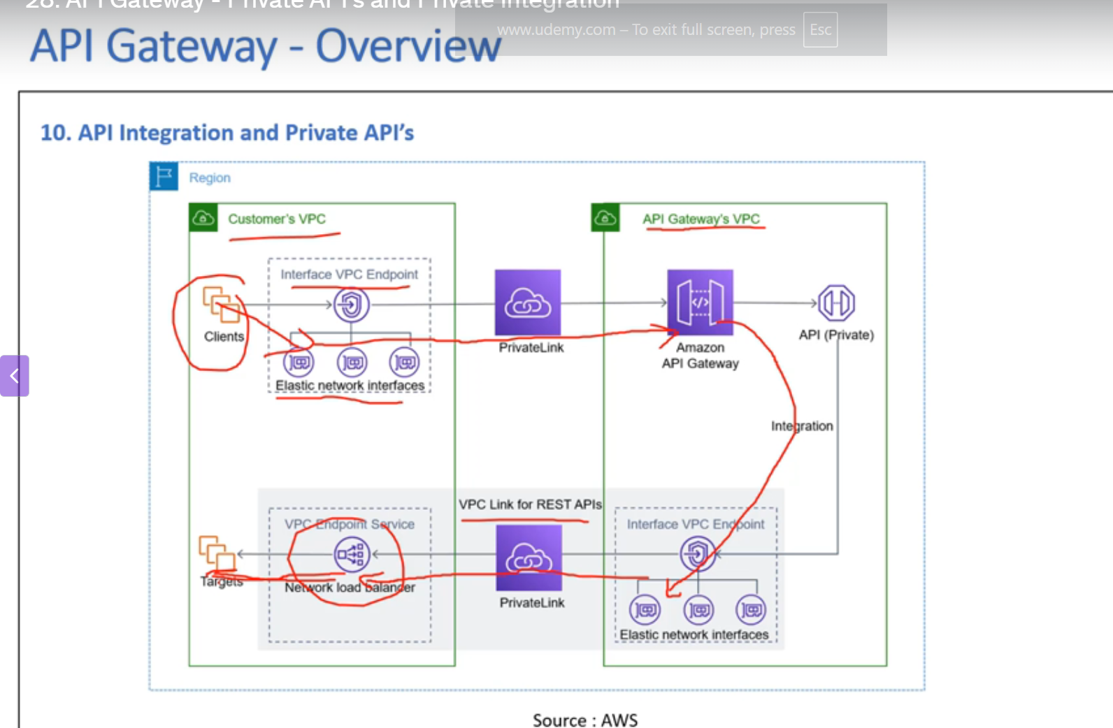

* So you have the client, say, an EC2 instance in a customer VPC, you create an interface VPC endpoint and as part of that, some enis get created.
* So the traffic is routed from the client's EC2 to this ENI and then through the PRIVATELINK, the requests are sent to Amazon API Gateway, which is in the Amazon API Gateway VPC.
* Then say this Amazon API gateway is trying to connect to a back end. So again, you will create the interface VPC endpoints and this traffic will be routed to the ENI from using the VPC link for Rest APIs.
* You can create this connection through the private link and you will have to create a network load balancerto which all this traffic would be routed from this to this NLB and then from the NLB, you could route

the traffic to this target group that you have within the customer VPC.

API Gateway 🡪 REST API private 🡪**API name**

Name: **privateAPI**

**API endpoint type : Private** (Private APIs are only accessible from vpcs)

**VPC endpoint**

<https://905418111046-p2xmdjap.us-east-1.console.aws.amazon.com/vpcconsole/home?region=us-east-1#Endpoints>:

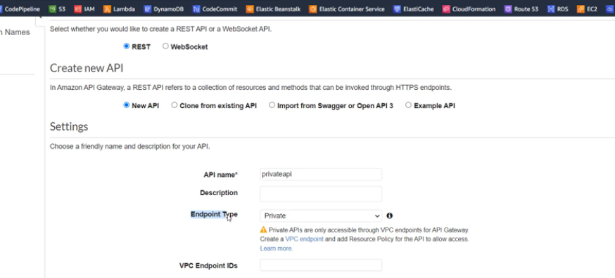

**Name of the vpc endpoint**: vpcendpoint

**Type:** AWS services

**Services: com.amazonaws.us-east-1.execute-api**

**VPC: Any VPC**

**Subnets**( 2/6)

[**I**](https://docs.aws.amazon.com/en_gb/console/vpc/endpoints/interface)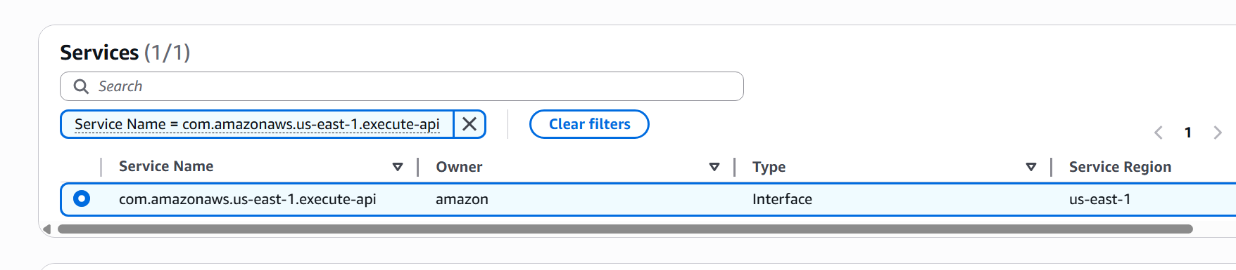

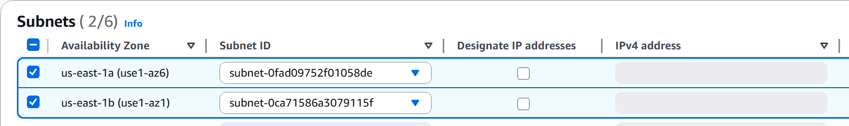

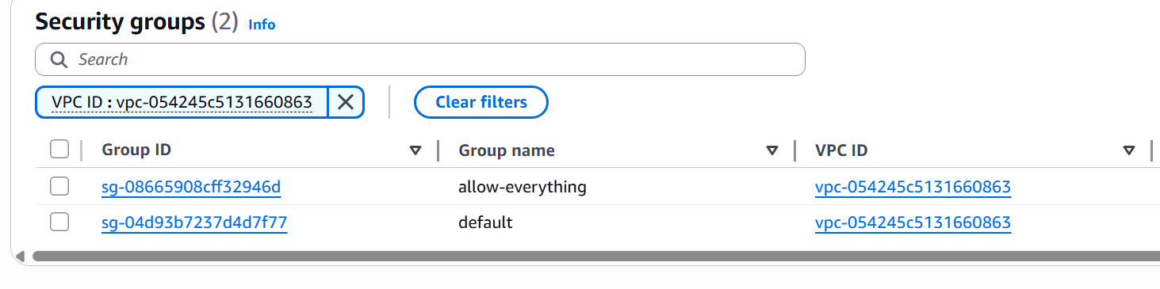

**Policy**

[**Info**](https://docs.aws.amazon.com/en_gb/console/vpc/endpoints)

VPC endpoint policy controls access to the service.

Tags:

Create VPC

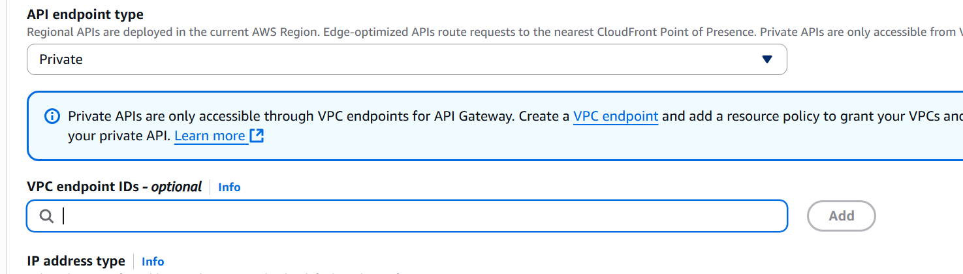

Create API

